Sunflower Activity A
Name: ________________________
Date: _________________________

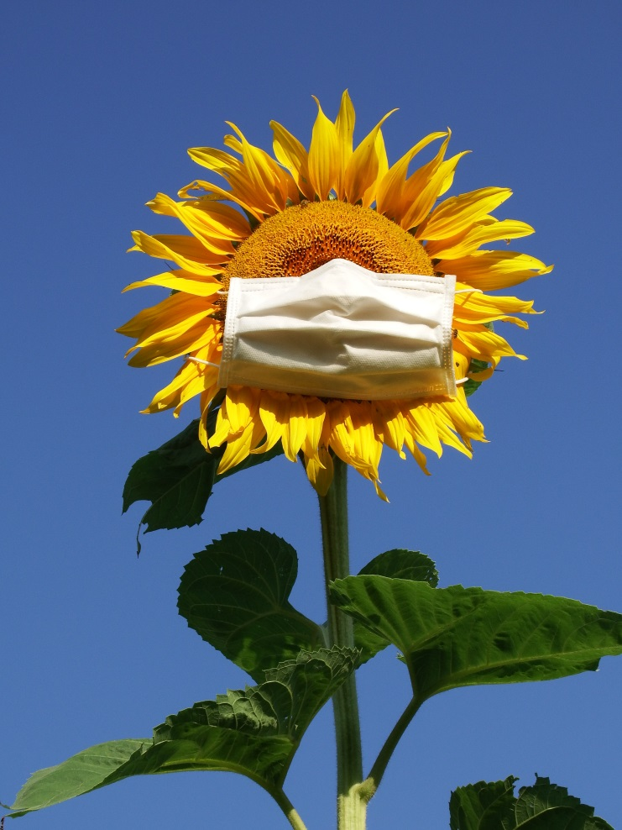

1. What would you name this sunflower?
______________________________________________________________________________
2. How do you think the sunflower feels? Why?
____________________________________________________________________________________________________________________________________________________________

3. Draw a sunflower on the back of this page. Be sure to include something unique and name it!
Sunflower Activity B
Name: ________________________
Date: _________________________
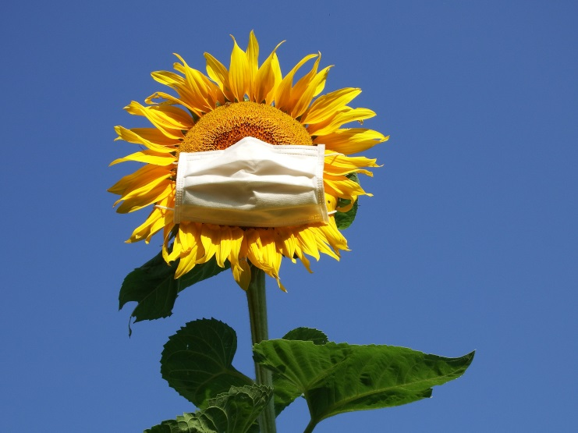
Shine on!

1. How do you stay positive during hard times?
____________________________________________________________________________________________________________________________________________________________
2. How have others helped you during rough times? How would you like others to help you?
____________________________________________________________________________________________________________________________________________________________
3. How do you help others during hard times?
____________________________________________________________________________________________________________________________________________________________

4. Design a poster on the back of this page.
Incorporate a strong phrase that will encourage others!

